**Sample Email**

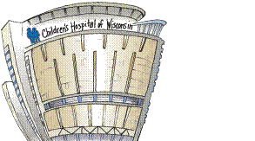

Hello Spring MU Clinical Group,

Just wanted to welcome you to Children’s and give you an early heads up about this fall’s clinical.

Plus there are a few things you need to have completed **BEFORE** you come on January 17th. (please read the attached letter)

I just wanted to introduce myself to you.  My name is Tracy Blair MSN, CNS, RN, CPN, CNOR.  I’m an APN that has worked at Children’s Hospital for over 30 years.  I’ve worked on a medical-surgical floor, NICU, and for the majority of my nursing career in the operating room.   I’ve been teaching for UWM for over 5 years and Marquette for over 20 years.   I am a mother of six, with my oldest being twenty-four and my youngest at fifteen, so I’m rather busy at home.

I’m really excited about this clinical for several reasons.  This clinical is a very unique one.  In this perioperative clinical we are able to spend time in four specialized areas at Children’s.  You will spend time in Day Surgery (pre-op), Surgery, Recovery room and Phase II (post-op).  This clinical has been around over 10 years now, so it’s very well established.  You will get to experience Perioperative nursing as a full entity.  You will get to witness surgeries (Anatomy 101) and also partake in a lot of assessments, start IVs, place Foleys, prepping , positioning, hand-offs and so much more.  If you want an early start to seeing what is coming in the near future, you can visit my website for this clinical: <https://sites.google.com/view/chwperioppediatricsinfo/home>

I was also wondering if you could pass along a few things about yourself. **Some things you enjoy doing, areas in nursing that interest you, and what your family life is like**.

I’m going to be introducing you to the staff via emails**,** so I would like to get this information by **January 16th.**

**You can just cut and paste the boxes-adding your information 😊**

I’ll start first:

|  |  |  |
| --- | --- | --- |
| **Family Life:** | **Areas of Nursing:** | **Some things you enjoy doing:** |
| Mother of six kids ages 24 to 15, Married to Brett (my husband) for 25 years. We own a cleaning company that cleans mostly country clubs, new construction homes and offices. Our Goldendoodle’s name is Cooper. | I’ve have always enjoyed pediatrics since my clinical at the old CHW located down by MU. I have worked in both the ER and NICU. I also taught for Concordia on West 12 and UWM on West 9. For many years I worked second shift as the PM supervisor in the OR along with being their Educator in the OR. I also help out occasionally at the Children’s Surgicenter and staff in the main OR. | I really enjoying doing things with my family.  I have coached soccer, softball and basketball for years now; I have my E license in soccer. I was elected onto the Muskego Norway School Board, CESA 1 Board of Control and City of Muskego’s Library Board.   I teach CCD at St. Leonard’s Church-9th grade Morality class and I’m on their Athletic Board. I play volleyball on Sunday nights too. At times I’ll binge watch shows on Netflix- currently its Ted Lasso |

As you are aware the clinical time has been moved up to 5:45 am due to the time the patients come in for surgery. But I would like for the **first day to meet at 7:30 am** instead.

That day we will be training in Epic (don't forget to bring your ear buds with 3.5 mm jack) and going over a lot of orientation information.

I’ve attached an information sheet for you to get to know Children’s.  You will need to wear a mask and eye protection while you are at Children’s in the perioperative area.

Marquette has agreed to purchase the N95 mask for you (for specific cases) and you will received this on your first day of clinical.  You are responsible for your eye protection.

Amazon does sell these, but you can purchase them from wherever.  Here is a link from Amazon: <https://www.amazon.com/s?k=eye+protection&ref=nb_sb_noss_1>

Please read the “First Day” attachment, it will tell you what you need to bring to clinical and where you need to go.

Here is a map to help you find our campus:

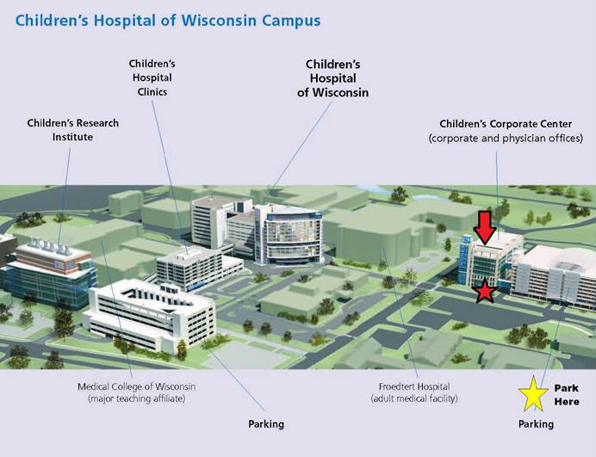

Please take a few minutes to respond to this email and I look forward to meeting you all soon. Tracy