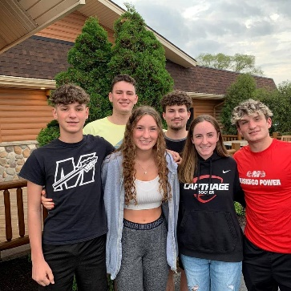
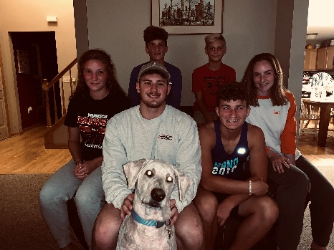

Marquette University
College of Nursing
Nursing 6976:
Transition to Nursing

Perioperative Nursing Clinical

First Clinical day: May 23, 2023 at 7:30 am

Parking: When you enter the parking structure you will see a bar that is down. You will need to press the intercom button to get the security guard’s attention. Let the security guard know that you are a new nursing student and the bar should rise. You will then be able to park in the structure at no charge. You need to park on the top level- the 8-9th level. Remember that you are NOT to park in the parent/visitor’s parking lot (located on Watertown Plank road).
On the first clinical day, we will initially meet on the second floor of the Children’s Corporate Center (corner of 92nd and Connell Avenue) on the second floor by Seven Sisters.
Park on the 8-9th floor, take the elevator to the 2nd floor,
walk straight ahead. Here are directions to Children’s:
https://childrenswi.org/location-directory/locations/hospitals/milwaukee-hospital

Dress code: You will need to wear your clinical uniform on this day.

What to Bring: Please bring the following with you as well:

- MU nursing syllabus (can be electronic)
- Student Nurse Orientation Material (Print pages 1-3)
- CHW Orientation “To Do List” (Print)
- Ear Buds with 3.5mm jack for Epic Training

The on line information will take you close to two hours to complete, so please allow some time to complete this. We will be getting trained on Epic May 23rd. You will receive your CHW photo ID on the first day of clinical.

NOTE: You will not be able to begin clinicals at CHW unless all health requirements and current CPR certification is documented by Marquette. If you have concerns related to this, you must contact the School of Nursing PRIOR to starting clinicals.

This clinical is located in four separate areas, day surgery, OR, recovery room and Phase II. You will be able to interact with several different roles in the Perioperative setting. Each day will be new and exciting.

If you have any questions, please do not hesitate to contact me.

Tracy Blair, MSN CNS RN CPN CNOR Email: tblair@childrenswi.org

Work Phone: 414-266-4739 Pager: 414-907-2777 Cell Phone: 262-501-2647

And Yes, those are my kids in the pictures

